**CAD USER**

**DOCUMENT**

**For**

**SONA FOODS**

Date: **Dec 2019**

Author: **ASHVINI BADHE**

**DOCUMENT HISTORY**

| **Revision** | **Date** | **Created / Updated By** | **Description** | **Approved By** |
| --- | --- | --- | --- | --- |
| 1 | 05th Dec 2019 | Ashvini Badhe | First Draft | Ruturaj Purohit |
|  |  |  |  |  |

1. **Save SolidEdge part in Teamcenter**

Open SolidEdge 2020

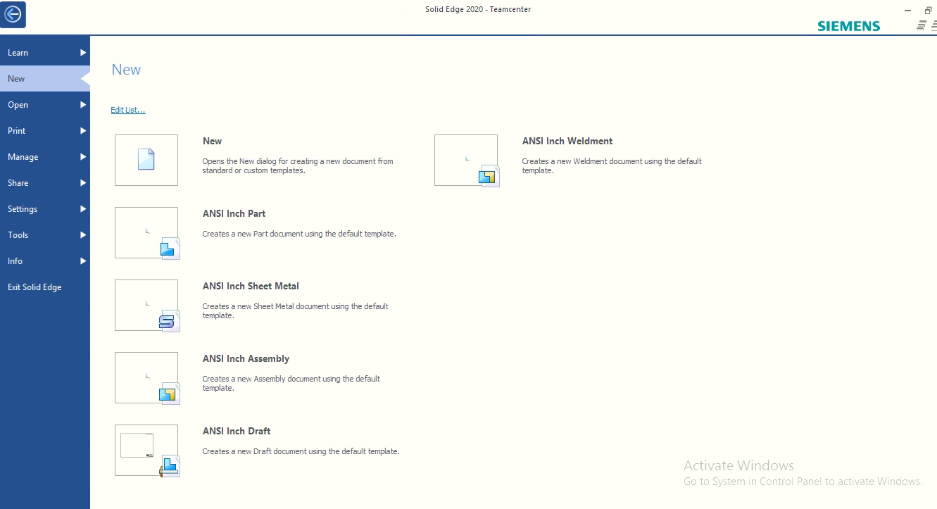

Click on New, the login window will appear

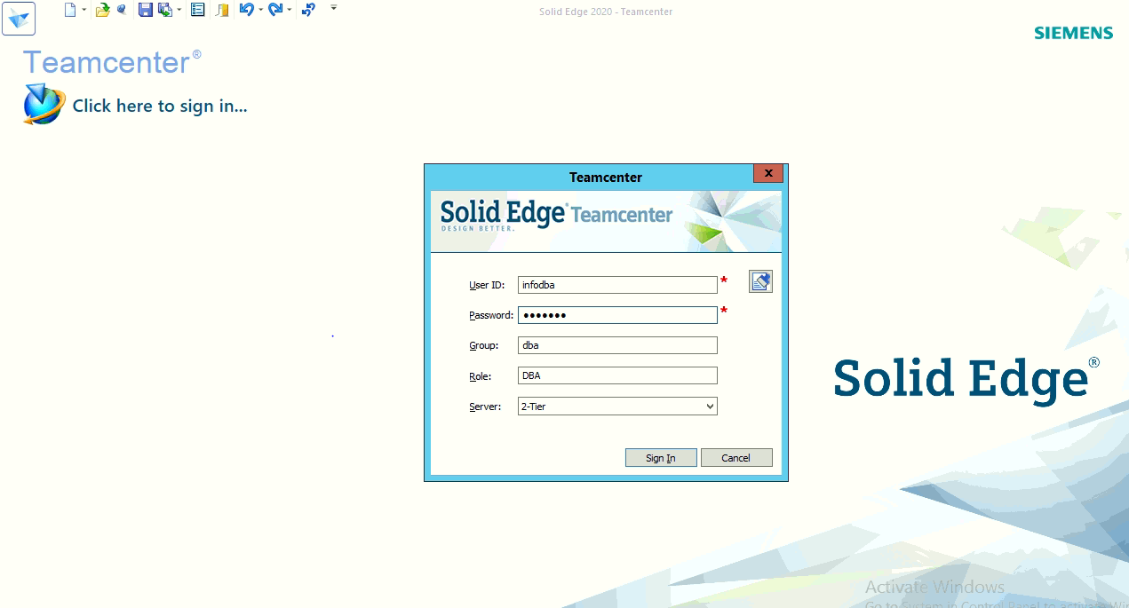

After successfully Login, following window will appear

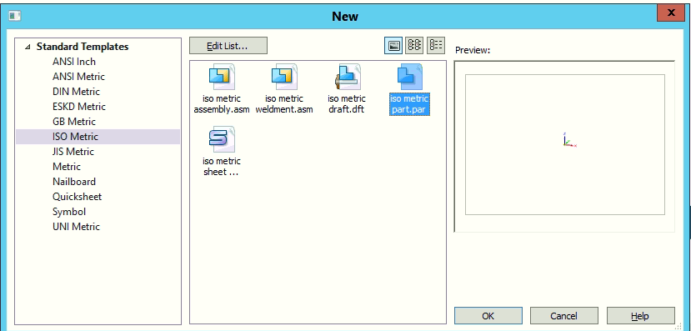

Select ISO Metric and ISO Metric Part.par and click on OK button

Create a part and save

Click Assign All then Validate and then Perform Action

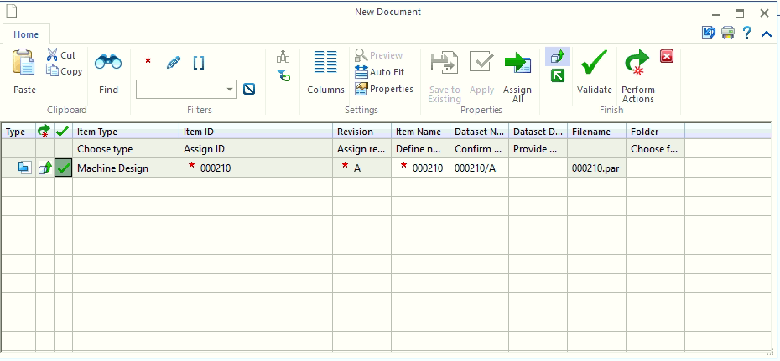

In Teamcenter Search the ID and it look like

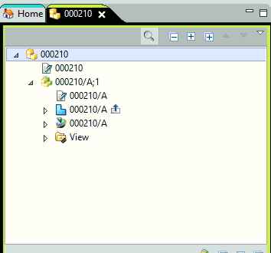

1. **Save SolidWorks part in Teamcenter**

Open SolidWorks 2018

Click on File 🡪 New

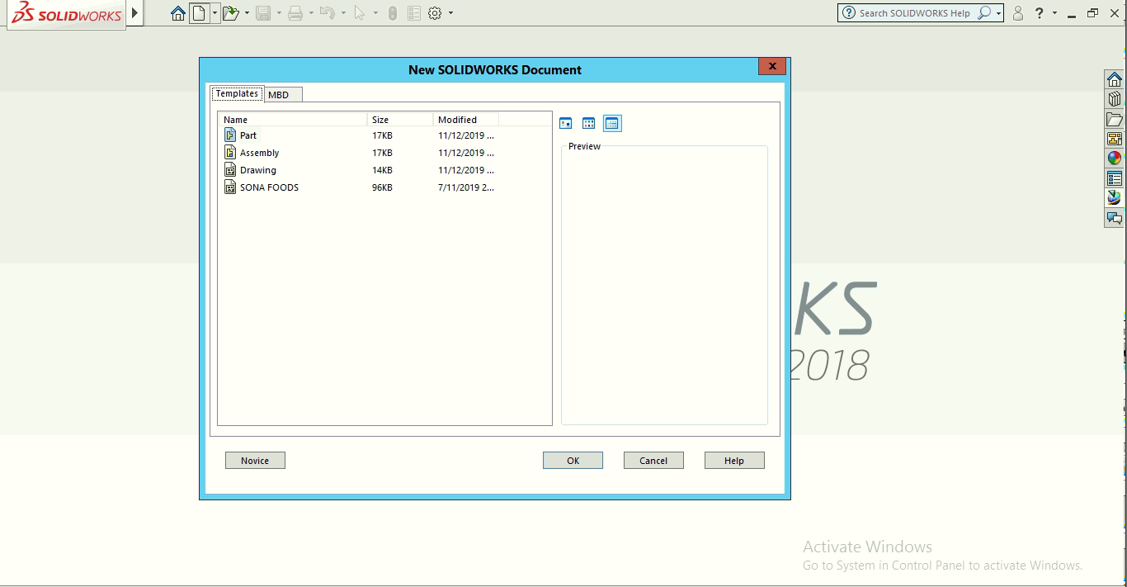

Select the Part and press OK button

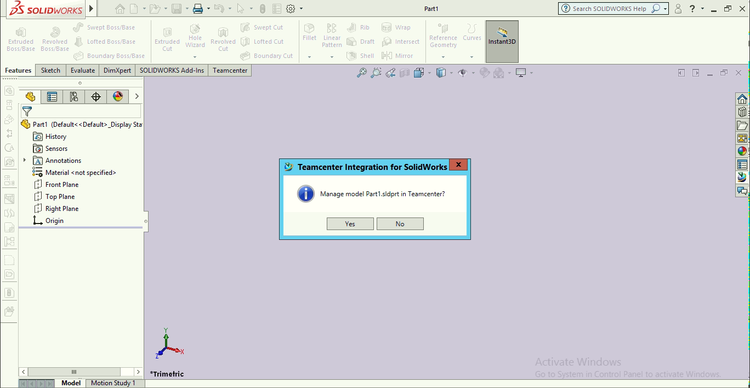

Click on Yes button

Enter the credentials

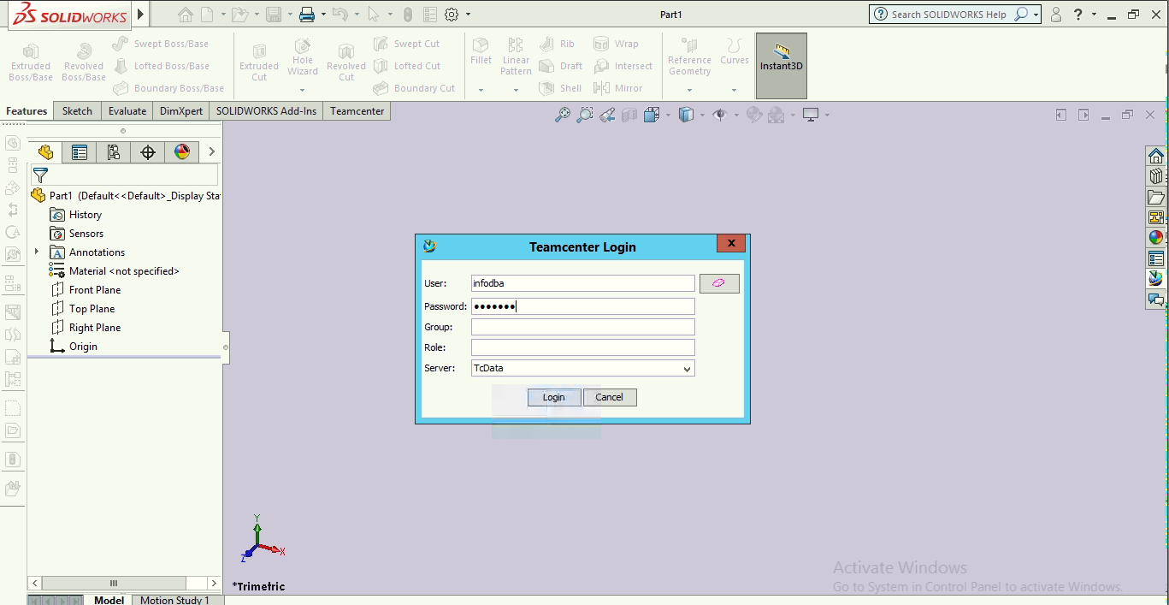

Click on Login button

Click on Sketch tab

Give Item ID and Name

Give the desire Teamcenter folder and work folder

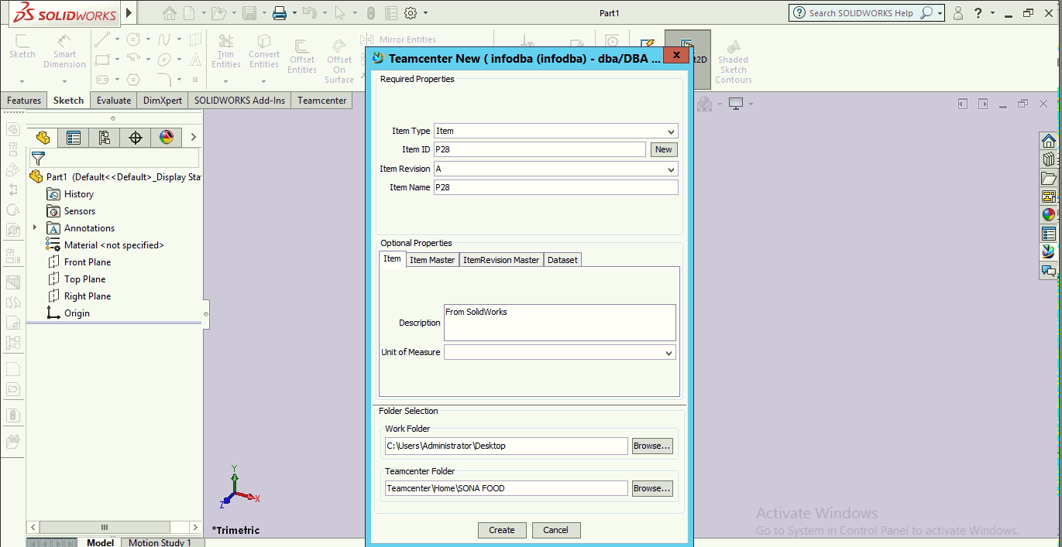

Press on Create

Draw a part

Click on Teamcenter icon at the right side

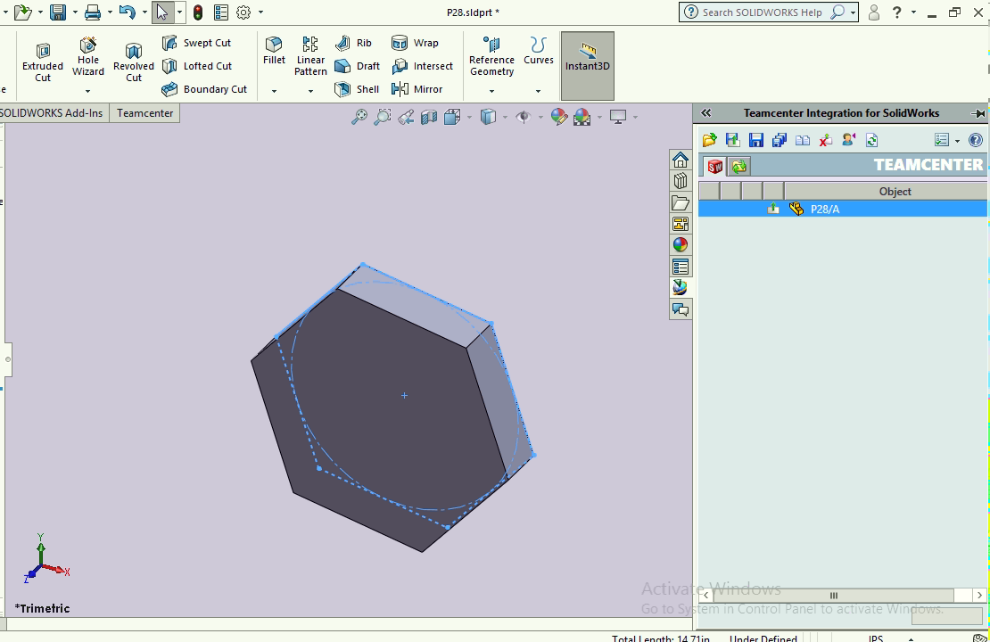

Click on Save button

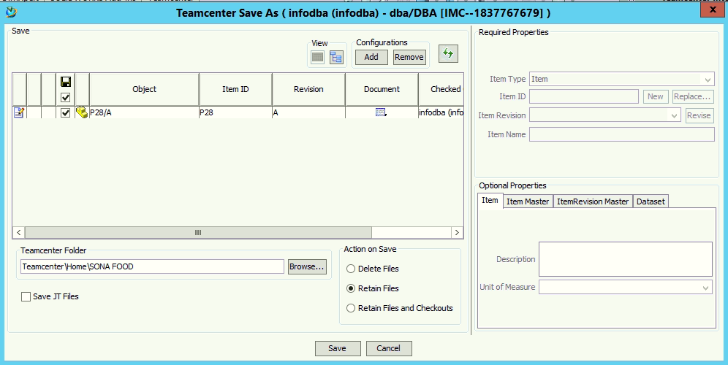

Click on Save JT Files check box

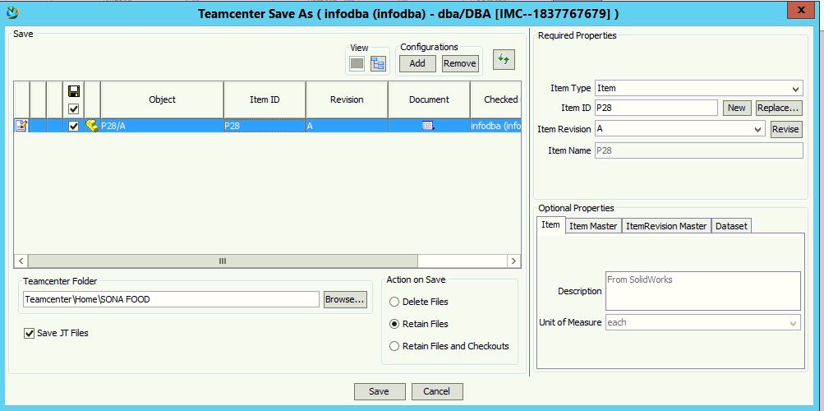

Click on Save button

Open the Teamcenter

Go to SONA FOOD folder and open that item

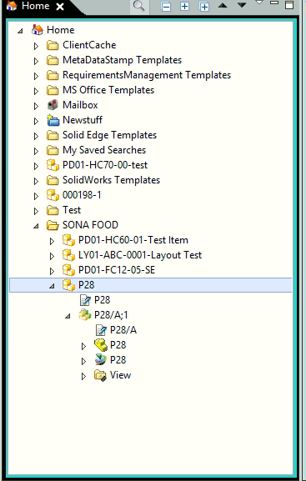

For create Drawing click on New 🡪 Make Drawing from Part/Assembly

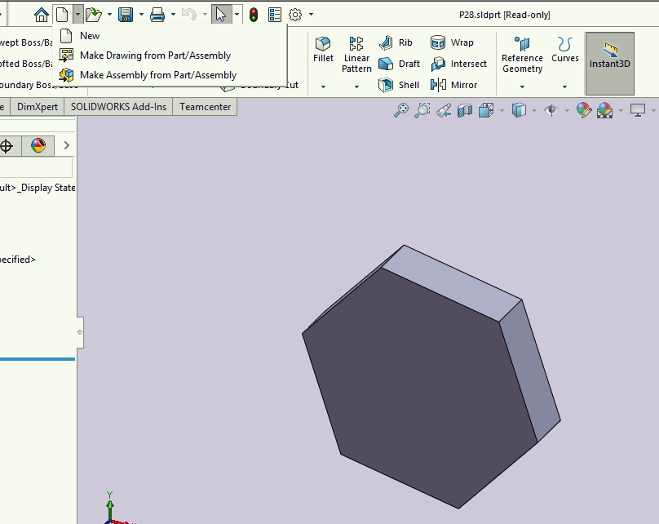

Following panel will open

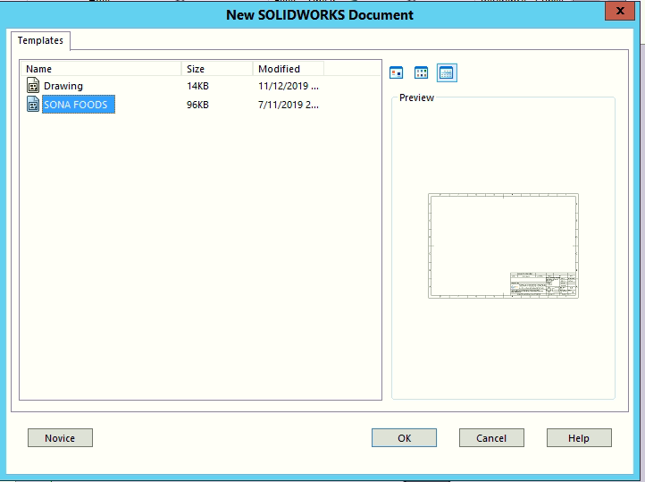

Click select Drawing template, click on Ok

Drawing creation panel will open

Fill the desire name for drawing

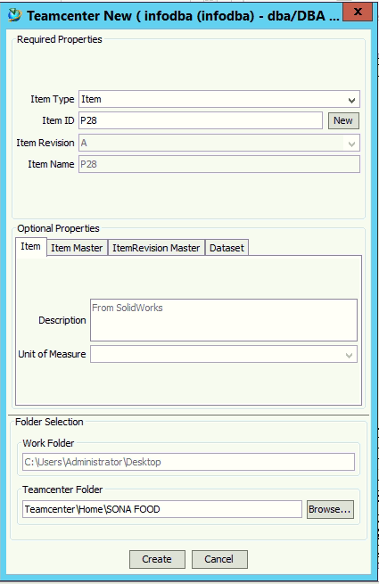

Press Create button

Draw the drawing and press the Teamcenter icon at the right side

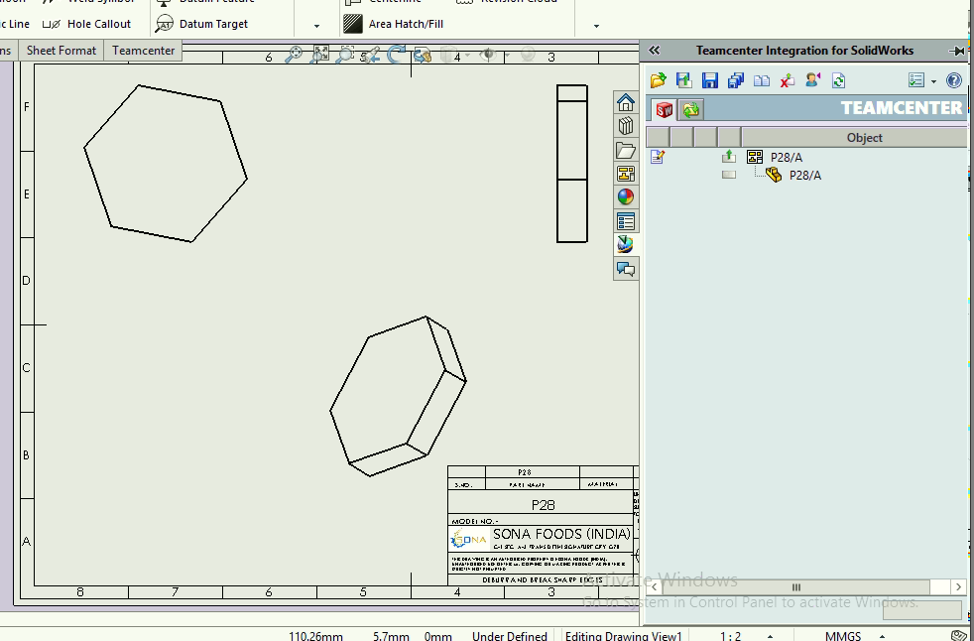

Click on Save button

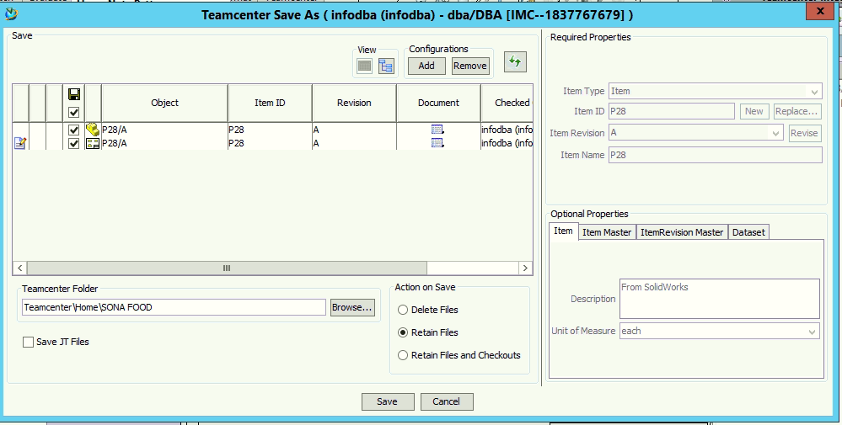

Click on Save

Open Teamcenter

